Stage 5 – Clark please, he doesn’t know any better
COURSE DESIGNER: Aaron Banks

SCORING: Comstock 40 rounds.
TARGETS: 17 cardboard targets, 6 Steel targets
SCORED HITS: 2 Best hits per carboard will be scored. Steel must fall to score.

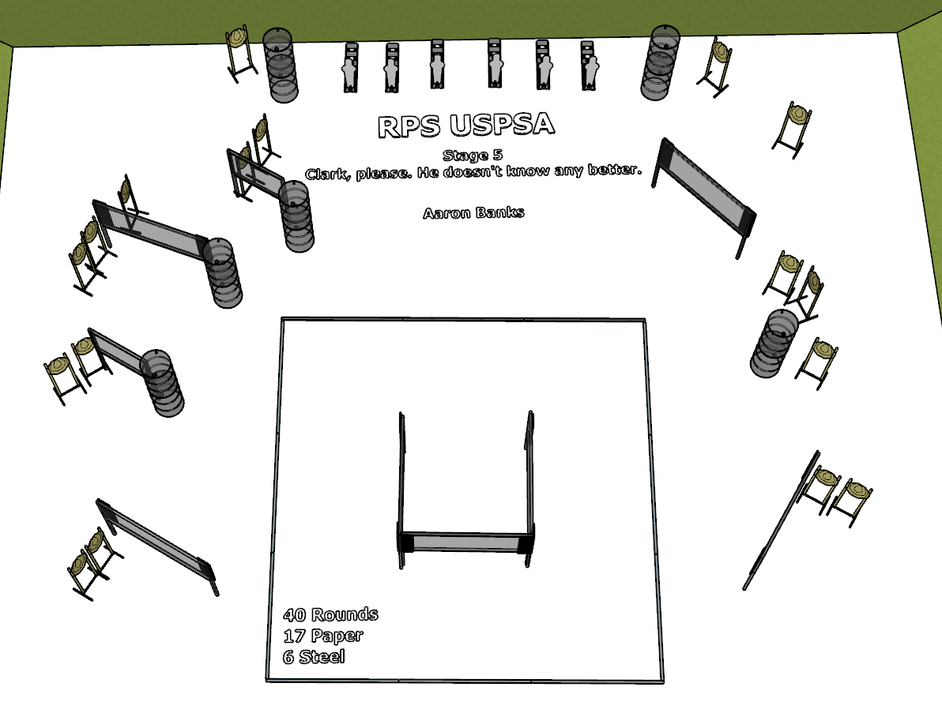

Written Stage Briefing:

Stage 5 –Clark please, he doesn’t know any better - is a 40 round, 200 point, Comstock Course. There are 17 cardboard targets and 6 steel targets. The best 2 hits per cardboard target will be scored. The steel must fall to score.
Start position Anywhere facing downrange.
Handgun: Loaded and holstered, wrists below belt.
PCC: Loaded, held in both hands, stock touching belt.

On the audible start signal, engage targets from within the shooting area.

USPSA / NROI Range Commands:
- Make Ready
- Are you ready?
- Standby
- If finished, unload and show clear.
- If clear, hammer down and holster
- Range is clear

Setup Notes:
14 Single Wall Stands
2 Double Wall Stands
7 Full Walls
2 Half Walls
17 Target stands / 34 target sticks
6 Large Poppers + bases
22+ barrels

